NAVIGATING EXCEL
Developed by: Sarah Gorman and Jordan Pedersen, UTL TALInt Students


^Don’t worry, we aren’t as grumpy as that guy
INTRODUCTION:
This workshop will build a strong foundation for using Excel. Following the results of the pre-workshop survey, we will focus on workbooks and worksheets, the menu ribbon, and file formats. We will also focus on keyboard shortcuts, best practices we’ve learned from our own work, and other excel “hacks” to help you master navigation! The terminology used in this workshop will also help you feel more confident searching online for ways to tackle new tasks in excel, and will be used in our later workshops.

LEARNING OBJECTIVES:
Participants will be able to...
- Navigate through excel workbooks and worksheets
- Understand the excel menu and where to seek help if needed
- Use keyboard shortcuts
- Understand the differences and advantages and disadvantages of various file formats
AGENDA:
- Introduction
- Workbooks and worksheets
- Selecting data, copying, pasting and filling cells
- Moving around your worksheets
- The menu system
- Tips for populating your worksheet
- Working with different file formats and Formatting

SETUP:
Find your “Example Books” file in Windows File Explorer and double-click to open it in Excel. Please ask us for help at any point if you have any trouble!
We will do most of the exercises together in a “work along” format.

Introduction
What is Excel?
- Spreadsheet application for tabular data analysis and calculation

Why would you use it/when do we use it?
- Gathering information in one place, such as for project management
- Analyzing (sometimes large) datasets
- To create basic data visualizations

Advantages:
- Friendly to use, especially if you’re familiar with other Microsoft Office products
- Functionality is extensive (add-ins, formulas, pivot tables and data visualization, etc.)

Disadvantages:
- Does not ensure data integrity (it’s your responsibility to make sure data is clean, excel does not ensure quality by itself).

Workbooks and Worksheets
Utility:
- Opening, saving, and closing files in Excel is very similar to opening, saving, and closing files in other programs (such as Microsoft Word).
Terminology:
- An Excel file is called a workbook
- A workbooks contains worksheets
- Worksheets are accessible through worksheet tabs

workbook
worksheet
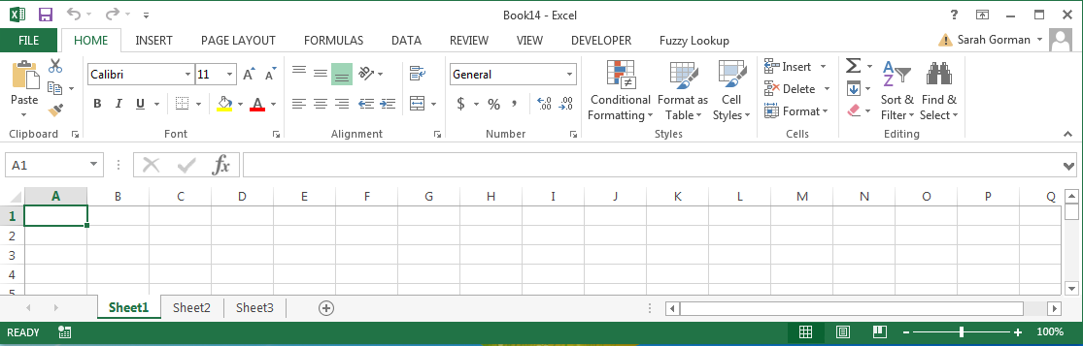

worksheet tabs
Exercise One:
- Create a new workbook
- Click File, then New, then Blank workbook, or press Ctrl + N
- Create a new worksheet
- Click the + symbol to the right of your existing worksheet tabs
- Rename a worksheet
- Right-click the worksheet tab and select Rename
- You can also use a left double click to highlight the current name and rename the sheet
- Re-order worksheets or move worksheets to new workbooks
- Click and drag the worksheet tabs to their proper locations one-by-one
- Delete a worksheet
- Right-click the worksheet tab and select Delete
- This cannot be undone!
- Close a workbook
- Click the X symbol in the top-right corner of Excel, or press Ctrl + W
- Save a workbook
- Click File, then Save, or press Ctrl + S
- You may be prompted to choose a save location and give your file a unique name
- If you want to save as, because you do not want the changes you have made to affect the original data, or because you want to change the file type (more on this at the end of the workshop!), click File, then Save As, or press F12 on your keyboard.
Tips:
- You can also copy a worksheet, which is a great idea to keep your original data safe from any changes you might make as you clean it up! To do so, right click on the worksheet you wish to copy, select Move or Copy. In the new box that pops up, select Create a Copy, and click on OK. Rename your new sheet to reflect that it is the copy.
- It is a good idea to keep each of your workbooks focused on a single, cohesive topic. Instead of storing information about your daily tasks, budget report, and reading lists in three sheets of a single workbook, store it in separate workbooks. This will make the information easier to find later on.

Selecting data, copying, pasting and filling cells
Utility:
- We must select data before we can work with it.
- Copying, pasting and filling cells is important if you are creating your own spreadsheet with your own information
Terminology:
- Excel worksheets are composed of cells, located in columns and rows
- Each column is labelled with a letter, and each row is labelled with a number
- Each cell has a cell address composed of its column letter and row number (e.g. B4, D5, or E4)
- A group of multiple cells side-by-side is called a cell range
columns
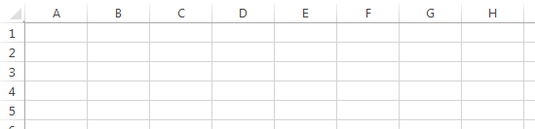

rows

cells

B4
E4
cell address

D5
cell range

Exercise Two: Selecting cells and moving through excel
- Select cell B4 in the worksheet Book List 3
- Click the cell
- Select row 7
- Click the row number
- Select a cell range which starts at A13 and finishes with G24
- Click and drag, or click, hold Shift, click
- Remember you can click cells, column letters, or row numbers
- Select non-contiguous cells, columns, or rows
- Click, hold Ctrl, click
- Select the entire worksheet
- Click the grey triangle in the top left corner of the sheet
- Select only the area that has information
  - Select any cell with information in it, and press Ctrl + A

Exercise Three: Copying, Pasting and Filling Cells
- Select Row 5 in Book List 3, and use Ctrl + C or right-click and Copy to copy the row
- Select Row 27 and use Ctrl + V or right-click and Paste.
- Pasting can be done in a number of ways, including pasting only the values, or formatting. One type of pasting that can be quite useful is Transpose, because it changes the way that you’ve oriented your table so that rows become columns and columns become rows.
  - Select all the cells that have information in them in the Publication Date, Language, and Page Count Columns in Books List 3. Use Ctrl + C to copy.
  - Create a new worksheet
  - Right click in cell A1 and under the paste options, and click on transpose (note, if you hover over any of the options you should see what they look like).
- Filling Cells:
  - Select cell B3 and hover your mouse over the bottom right hand corner of the cell. You’ll notice the cursor change. Click and hold, dragging your mouse down to fill the cells below to cell B30.
  - You’ll notice a menu pop up at the bottom right of B30. Click on it.
  - Experiment with the different types of fills. What would each be good for?
Tips:
- It is possible to combine keyboard shortcuts and selection mechanisms to get more power out of Excel. Try these example shortcut combinations to see what they do:
- Click a cell, then press Ctrl + Shift + arrow key (this will select everything from the cell you first selected to the bottom of your worksheet)
- If you ever need to deselect a cell, especially after you have copied it, you can use Ctrl+D

Moving around your worksheets
Utility:
- If you have a lot of information, you will want to be able to navigate quickly and easily through the cells in your worksheet.
Terminology:
- You always have at least one cell in your worksheet selected
- The selected cell is known as the active cell(s)
- In a cell range, the unshaded cell is the active cell
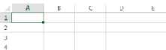

selected, active cell

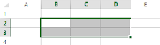

active cell
selected cells

Exercise Four:
- Move through cells one-by-one
- Pressing enter will move down, Tab will move you to the right, and Shift + Tab to the left, or the arrows keys to move in any direction
- Move down columns quickly
  - If you have a large worksheet, you can move up and down the sheet using the Page Up or Page Down keys on your keyboard (which will move you approximately 40 rows at a time).
- Jump to cell A1
- Press Ctrl + Home
- Move to the edge of a data region
- Press Ctrl + arrow key, pressing the arrow key for the direction you want to go
- Move between worksheets quickly.
  - Click Ctrl + Page Up to move to the next worksheet on the left, or Ctrl + Page Down to move to the next worksheet on the right
- Are you at the bottom of the page and you want to get back to the top?
  - Either press Ctrl + Home, or Ctrl + the up arrow (twice).
  - Similarly, Ctrl + End will take you to the last cell that is populated in a row
Tips:
- Working with keyboard shortcuts if you plan on navigating large spreadsheets makes life much easier. Once you become comfortable with them, keyboard shortcuts will spare you a lot of time and frustration scrolling and clicking, and they will form the basis for you to become an expert user of Excel.

The Menu System
Utility:
- Excel’s menu system, referred to as the “Ribbon,” gives you point-and-click access to all the tools and features of Excel. There are hundreds of commands available, but don’t feel pressured to learn them all. Most people regularly use only a small number of commands.
Terminology:
- The ribbon consists of a series of tabs
- Tabs contain command groups
- Command groups may be accompanied by dialog box launchers to expand the selection of commands
tabs
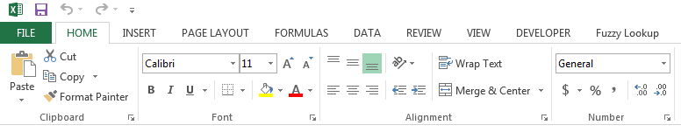

command group
dialog box launchers

Exercise Five: Use the menu to execute a command
- In the worksheet “Books List 3” we will use the menu to help us remove the 4 duplicate titles for “Analysis of Health Surveys”
- Select the Column you want to remove the duplicates for (“ISBN”). Click on the Remove Duplicates command by clicking on the Data tab. (You can find it by locating the command group Data Tools, then finding Remove Duplicates)
- You will be prompted to either Expand the selection which means it will delete the entire row where there are duplicates in the title column, or Continue with the current selection which means it will only delete the duplicates in the title column, leaving the rest of the row untouched and a blank space in the title column where the duplicate once was. We want to select Expand the selection.
- For the purposes of this exercise we will select only the “ISBN” where we want to remove duplicates. To do this click on the Unselect All button, and the click on the checkbox beside ISBN. Click OK.
Exercise Six: Find a new command by searching online or with Excel Help
- To open Excel Help, click the question mark in the top right corner of Excel, or press F1
- Finding new commands takes trial-and-error and luck. Don’t be afraid to ask for help!
- Try finding the Insert Column Chart command by typing into the search bar and hitting the enter key on your keyboard.

Tips for populating your worksheet
Utility:
- Although typing, copying, pasting and filling cells can be easy to do, these are some useful tips for common problems we have encountered
Exercise Seven: Using Alt to input multiple lines in a cell.
- Sometimes you will not want to have one long run-on sentence in a cell. To create text with multiple lines, begin typing your last name in cell A28 of the “Books List 2” sheet.
- Hold Alt and Enter. You will now be typing in a new row. Write your first name on the second line.
Exercise Eight: Use ‘ to avoid automatic formulas
- If you are working with files that contain an equal sign at the beginning of the field (we encounter this all the time when we export MarcEdit records to analyze in spreadsheets), you will need to “escape” the equal sign.
- In a new worksheet, try to type “=245 10$aCataloging” in cell A1. Hit enter when you have finished typing.
- You will get a message that looks like this:
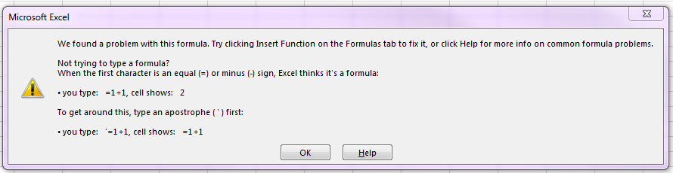
- Click OK. We will now insert the single quote ‘ at the beginning of the field. Hit enter again. Excel will now recognize this as an intentional equal sign, and will also not display the single quotation.

Tips:
Some essential commands for populating worksheets include:
COMMAND | LOCATION | USE | SHORTCUT
Inserting cells | Home tab, Cells command group | Can be used to insert rows, columns or individual cells. | Select an entire row/column that you want to add a row/column above or left of it, and then press Ctrl plus the + key
Deleting Cells | Home tab, Cells command group | Can be used to delete rows, columns or individual cells. | Select the entire row/column you want to delete (for several at once press Ctrl key to select all of them) then press Ctrl plus the - key
Wrap text | Home tab, Alignment command group | Rather than truncating text that spills into the next cell (Excel’s default), the column width will be kept and the depth will be adjusted so that all text fills it’s cell | N/A
Freeze Panes | View tab, Window command group | Keep a portion of your worksheet visible while you scroll through the rest | N/A

Working with different file formats
Utility:
- Excel can support many types of files. This is important because you may need to save your file in a non-proprietary format if you are sending it to someone who uses a different type of spreadsheet program, or if you are uploading the document to certain websites.
Terminology:
- (Common) Excel File Formats
  - .xlsx Excel Workbook for Excel 2010 and 2007
  - .xlsm Excel Macro-Enabled Workbook for Excel 2016, 2013, 2010, 2007
  - .xls Excel 97- Excel 2003 Workbook
  - .xltx Excel Template
- (Common) Text File Formats
  - .txt Text (can be Tab-Delimited, Unicode, etc.)
  - .csv CSV (also known as comma delimited)

Exercise Nine: File Formats
- Saving as .csv file
  - Ensure you are on the first sheet of the workbook. Click on File in the ribbon menu, then click save as (or use the keyboard shortcut F12)
  - Decide on where you want to save your document, in this case we are going to save on the desktop so we can easily locate the file and delete it after our exercises.
  - Name your file “ExcelWorkshop” in the File name box
  - Click on the drop-down menu in the Save as type and select “CSV (Comma delimited, *.csv)”
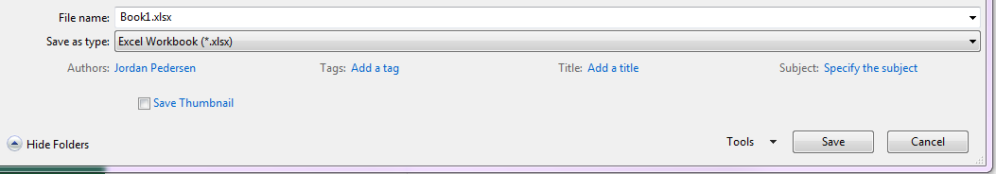
  - Click the save button
  - You will receive a message that looks like this:
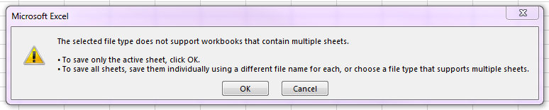
  - Click OK. You will notice this happens with many text file formats, because they are not rich text and therefore only support a single page of text characters. You may also get the message “Some features in your workbook might be lost if you save it as CSV”. Click OK.
  - Find your new .csv file on your desktop. Right click and choose to Open With Notepad. You’ll notice it is very ugly, but all of the textual information is still there, with each cell being separated by a comma.
  - Now right click on your new .csv file on the desktop, and Open (the default will be to open in excel). You’ll notice it is the same information, stored in a single worksheet, but with each piece of information in its own cell with no commas between them. This is because excel knows that when it opens a .csv, it is easier for people to read it without the commas and with all of the information neatly organized in rows and columns.

Formatting
Utility:
- Our focus is on making things readable, but keeping them in a functional format
- Some changes are “safe” as long as they are not used excessively – i.e. they will not prevent your file from being read in a non-proprietary file format (such as .csv, .txt), but some formatting is “unsafe” which can easily lead to misunderstandings.
Changes that only affect the display of your data (recommended, these are safe):
- Font and Font Size
- Wrap text
- Autofit column width
- Double-click on the grey line in between cell rulers to autofit the width
- Apply styles to headings
- Apply “normal” style to format as plain text
- Freeze and unfreeze panes
- Changing worksheet tab colours
Changes that can affect the structure of your data or convey meaning (be careful, these are unsafe):
- Typographical emphasis (italics, bold, etc.)
- Background fill colour
- Merge and unmerge cells
- Add new line within a cell
Tips:
- If you find yourself relying on visual techniques to organize and record information, challenge yourself to add description or put that information into words. For example, if you use a lot of colours, consider adding a legend to your spreadsheet. If you differentiate book titles with bold font and journal titles with italic font, consider supplementing this with a “type” column that says “book” or “journal” for each record.
- Other data best practices can be found in the Library Carpentries Tidy Data for Librarians curriculum https://jezcope.github.io/library-spreadsheets/ . To summarize those points:
  - Put all your variables in their own columns (i.e. “author”, or “ISBN”), and each item in their own row (i.e. one book per row).
  - Don’t combine multiple pieces of information in one cell. Sometimes it just seems like one thing, but think if that’s the only way you’ll want to be able to use or sort that data.
  - Use a separate worksheet for notes – having your notes at the top or bottom of the sheet can be misread as part of the data – especially if it is saved in a text format.

Concluding Exercise and Resources
Infographic timeline
https://templates.office.com/en-US/Infographic-timeline-TM16410237
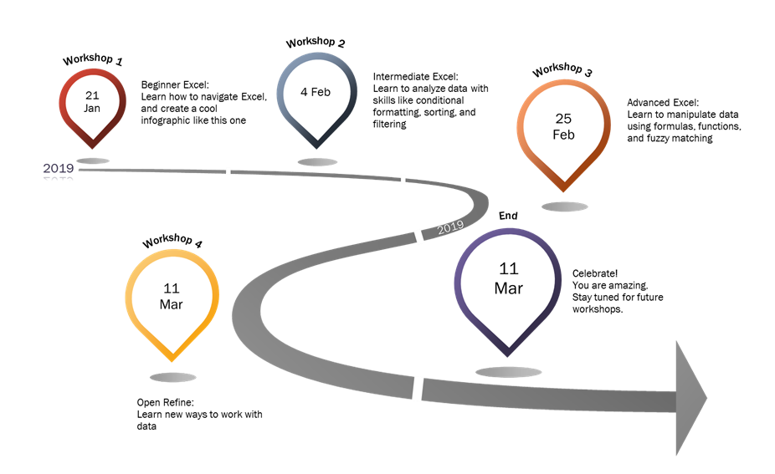

For more information about keyboard shortcuts in excel: https://www.absentdata.com/excel-keyboard-shortcuts/

